FBL1N- Vendor Line Item Display
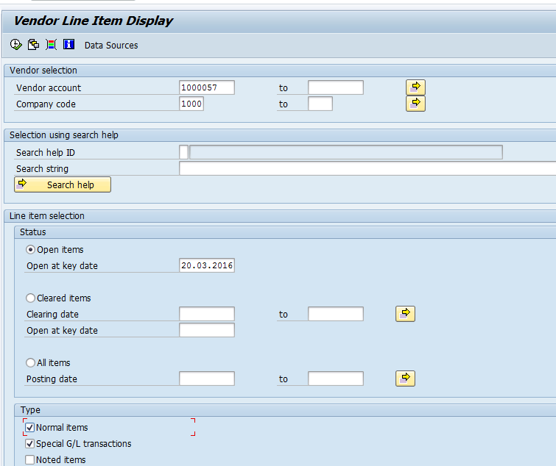
The following are the input criteria for extracting the Vendor line item display
Vendor Selection: Under this section
- Vendor Account: Input the Vendor Number in this field
- Company Code: Input the Company code
Line Item Selection: Under Line item section
- Open Items: Select Open items radio button
Type: Under this section
- Normal Items: Set the check box where system will display the invoice items(normal items)
- Special G/L transactions: Set the check box where system will display the information related to down payment etc.
Click on Execute

Vendor Open item Display
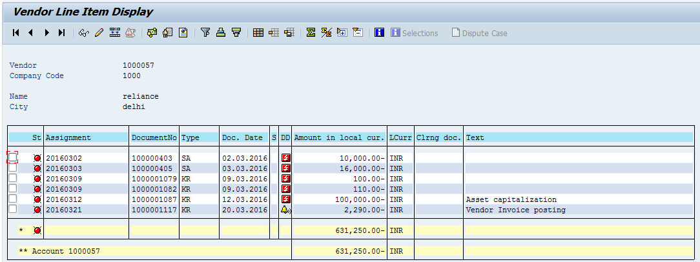
- Vendor Invoice will be displayed with Status as Open item in Red colour

FB08 – Reverse the Document
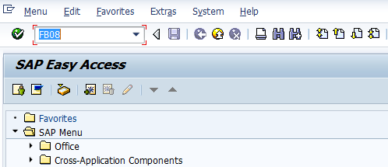
- Input FB08 in Transaction box and press Enter key

Reverse Document Details
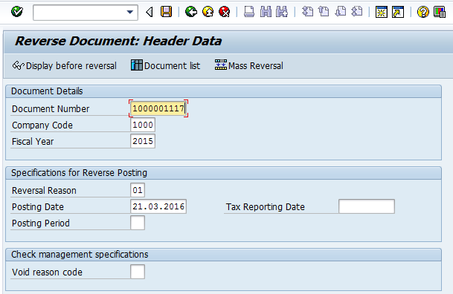
The following are the Input fields under the Reverse Document screen
- Under Document Details: In this section the input fields are
- Document Number: Input the Document Number(FB60 Document number) in this field
- Company Code: Input the Company code information in this field
- Fiscal Year: Input the transaction date in the Clearing date field
- Specifications for Reverse Posting: In this section the input fields are
- Reversal Reason: Place the cursor on this field and press F4. List of options will display. Select “01” Reverse in Current period option
- If we want to reverse the document in Previous period choose ”02” Reverse in Previous period
- Posting Date: Input the date for Reverse document
- Posting Period: Input the Posting period information
- Click on Display before reversal option
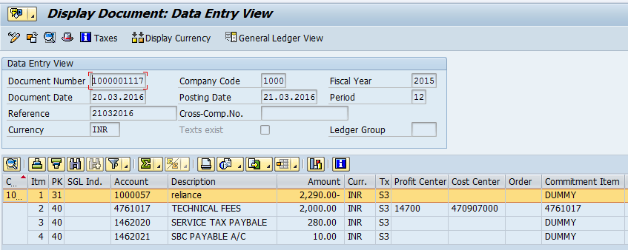
- System will display the transaction of the invoice posted in FB60. Press F3 or click on back option and click on Save option

Document Posting
- Document is posted, An information will be populated at the bottom of the screen

Document Display View
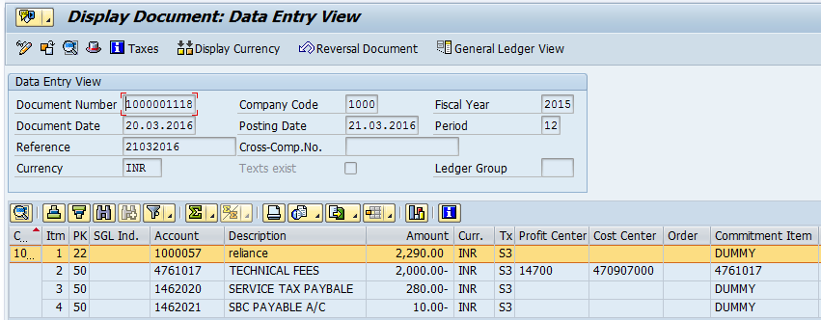
We can view the transaction in two ways:
- Display Document: From Menu bar select Document option it will display the options Change, Display, Post and Save as completed. Choose Display option. Document successfully got posted will get displayed
- Input FB03 in Transaction box and system will take us to Document Display screen. Input the Document number and Press Enter key. Document posted will get displayed.

FBL1N- Vendor Line Item Display
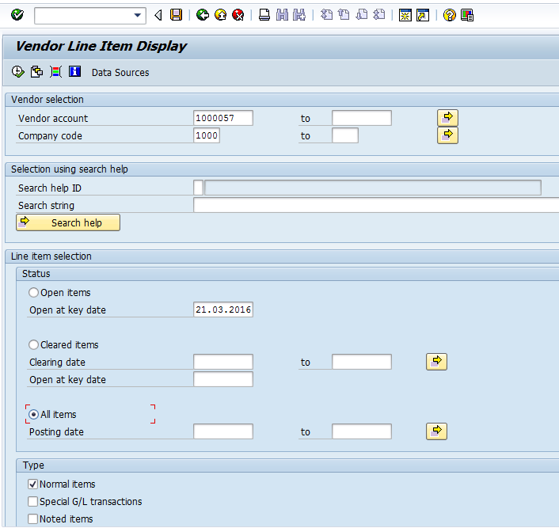
- Select All Items radio button and click on Execute button. System will display the Line items which are reversed and status will be displayed in Green colour

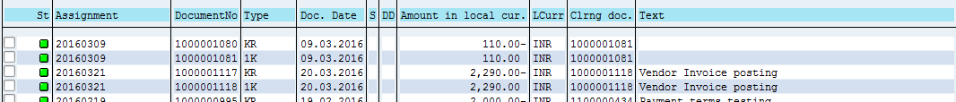
- Reversed Documents were posted with New Document Number 1000001118 and 1100000608
Manual End

